Project Planning Phase
Project Planning Template (Product Backlog, Sprint Planning, Stories, Story points)

Date | 03 February 2026
Team ID | LTVIP2026TMIDS24384
Project Name | I Revolution_ A Data-driven Exploration of Apple's iPhone Impact in India using tableau
Maximum Marks | 8 Marks

Product Backlog, Sprint Schedule, and Estimation (4 Marks)
Use the below template to create product backlog and sprint schedule

Sprint | Functional Requirement (Epic) | User Story Number | User Story / Task | Story  Points | Priority | Team Members
Sprint-  1 | Data Collection | USN-2 | As a user, I can load data into the processing environment | 1 | High | All
Sprint-  2 | Data Preprocessing | USN-3 | As a user, I can handle missing values in the dataset | 3 | Medium | Bavireddy Vaishnavi
Sprint-  2 | Data Preprocessing | USN-4 | As a user, I can encode or map categorical variables appropriately | 2 | Medium | All
Sprint-  3 | Making Graphs / Visualizations | USN-5 | As a user, I can build the initial model based on processed data | 5 | High | Bavireddy Vaishnavi, Bhattu Jagadeesh Prasad
Sprint-  4 | Dashboard & Stories | USN-6 | Dark UI with eye-feasted color palette | 6 | High | All
Sprint-  5 | Report & Documentation | USN-7 | The step-by-step guide documentation | 7 | Medium | All

Project Tracker, Velocity & Burndown Chart: (4 Marks)

Sprint | Total Story Points | Duration | Sprint Start Date | Sprint End Date (Planned) | Story Points Completed (as on Planned End Date) | Sprint Release Date (Actual)
Sprint-1 | 20 | 1 Day | 28 January 2026 | 28 January 2026 | 20 | 28 January 2026
Sprint-2 | 20 | 1 Day | 29 January 2026 | 29 January 2026 | 20 | 29 January 2026
Sprint-3 | 20 | 1 Day | 30 January 2026 | 30 January 2026 | 20 | 30 January 2026
Sprint-4 | 20 | 1 Day | 31 January 2026 | 31 January 2026 | 20 | 31 January 2026
Sprint-5 | 20 | 1 Day | 01 February 2026 | 01 February 2026 | 20 | 01 February 2026

Velocity:
Imagine we have a 10-day sprint duration, and the velocity of the team is 20 (points per sprint). Let’s calculate the team’s average velocity (AV) per iteration unit (story points per day)
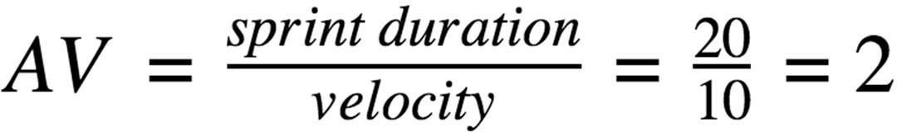

Burndown Chart:

A burn down chart is a graphical representation of work left to do versus time. It is often used in agile software development methodologies such as Scrum. However, burn down charts can be applied to any project containing measurable progress over time.
